Camera-Ready Articles Preparation Instructions for International Conference Industrial Engineering 2023

(Author’s) Name SURNAME*, Name SURNAME*, Name SURNAME**

* University, Faculty, E-mail: student.student@ktu.edu

** University, Faculty, E-mail: supervisor.supervisor@ktu.lt

Abstract
The manuscript should be written according to the below structure and formatted so that it is consistent with the INDUSTRIAL ENGINEERING conference’s Full Paper Template.
A structure with the following headings is recommended: Abstract, Keywords, Introduction, Experimental details, Results and discussion, Conclusions, References. There is flexibility as to the naming of the sections. Subheadings can be used when necessary.
The length of a manuscript is not limited but it should not exceed 3 – 5 pages including figures, references and abstract. Not less than 75% – 80% of the last page should be filled.
The introduction section should present the scope and objective of the paper and state the problem; briefly review the pertinent literature; describe the methods, and provide an overview of the main results of the work.
The methodology must be clearly stated and described in sufficient detail or with sufficient references.
The findings and arguments of the work should be explicitly described.
References should be numbered consecutively (numbers in square brackets) through the text and collected together in a reference list at the end of the paper. Please place the references according to their order of appearance in the text like here [1].
Keywords: this section shall contain maximum 5 words written in lower case separated by commas.
1. Layout
Times New Roman font should be used. The text should be typed in one column on A4 format sheets (210 x 297 mm). Leave 20 mm margins at the top, 17 mm at the bottom, 18 mm left and at right sides.
The title of an article should be printed in 16 pt (Bold), author's name – 12 pt (Bold), title of the institution – 10 pt (Italic), headings of the chapters – 10 pt (Bold), the body text and abstract – 10 pt, text of the tables – 9 pt, formulas in the text (using Microsoft Equation).
References should be numbered consecutively (numbers in square brackets) through the text and collected together in a reference list at the end of the paper. Please place the references according to their order of appearance in the text like here [1]. Use 10 pt, regular for the reference list. To list references, use ISO 690:2021 [5].
2. Figures and tables
The figures and tables shall be numbered, have a self-contained caption. Figure captions shall be below the figures (Fig.1); table captions shall be above the tables (Table 1). Please avoid placing figures and tables before their first mention in the text.
The text of figure captions shall be 10 pt high, Times New Roman and Normal. Name of the Figure should be centred.
Fig. 1 General view of a specimen with side grooves [2]
a b
Fig. 2 General view of a specimen with side grooves: a - title; b - title [2]
All the figures, graphs and photographs shall be numbered and referred in the main text. Abscissas and ordinates of all graphs shall be labelled with symbols and units.
All figures, graphs and photographs can be in colours as well as in black and white (or grey shades).
One-line spacing shall separate the figures and tables from the text.
Table 1. Mechanical characteristics of pipes main steel, weld and heat affected zone metal
Pipeline index | Pipe steel, weld and heat affected zone (HAZ) metal | Test temperature T, ºC | Yield stress , MPa | Ultimate stress  , MPa | Poisson’s ratio  ν | Young’s modulus  E, MPa
DU-300 | Steel 08X18N10T | 20 | 309 | 608 | 0.35 | 140300
 |  | 285 | 232 | 397 | 0.35 | 140100
 | Heat affected zone (HAZ) metal | 20 | 283 | 584 | 0.35 | 151500
 |  | 285 | 240 | 474 | 0.35 | 188800
3. Formulas
All equations and symbols in the text shall be written in Microsoft Word Equation (Insert ▶ Object ▶ MathType 6.0 Equation). An example of how to type formulas is presented below (1):
(1)
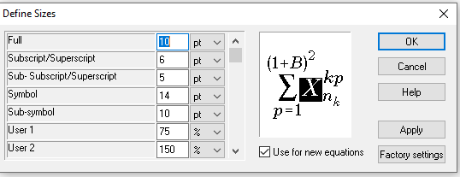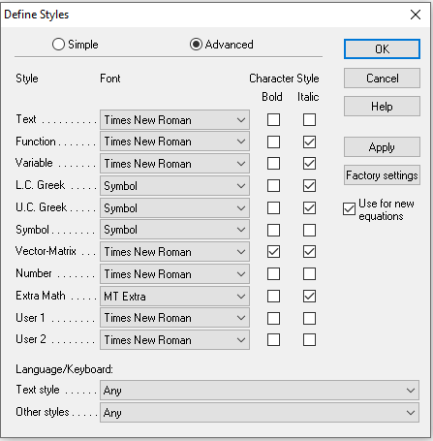
a b
Fig. 3 Define of formulae: a – sizes, b – styles

4. Conclusions
- Conclusions are numbered and formulated avoiding broad descriptions and presentation of non-essential information.
- We thank you in advance for the usage carefully of instructions for camera-ready articles, which can be sent for publication with minor modification.

References
- GALDIKAS, M. ir A. VILKAUSKAS. Research of aerodynamics characteristics of wind power plant blades. Mechanika, 19 (2013), 3, 324-331. ISSN 1392-1207.
- FELL, Robin; Patrick MACGREGOR; David STAPLEDON; Graeme BELL and Mark FOSTER. Geotechnical engineering of dams. 2nd ed. Boca Raton [Fla.]: CRC Press, 2018. ISBN 9781138749344.
- NAJAFI, M. Trenchless Technology Piping. Online. New York, USA: McGraw-Hill Professional Publishing, 2010. ISBN 9780071640886. Available from: https://www.accessengineeringlibrary.com/content/book/9780071489287. [viewed 2022-08-10].
- PAMULA, A. New Energy Demand Programs Acceptance – a Study of Residential Customers in Central Poland. Social Sciences. PDF: Online. 83 (2014), 1, 17-26. ISSN 2029-7319. Available from: https://doi.org/10.5755/j01.ss.83.1.6865. [viewed 2022-08-09].
- How to cite and prepare a list of references (ISO 690:2021). KTU library. Available from: https://library.ktu.edu/wp-content/uploads/sites/53/2017/12/ISO-slides-2021-EN.pdf. [viewed 2023-02-09].

