KTU Faculty of Mechanical Engineering and Design May 13, 2021, Kaunas, Lithuania
The International Young Researchers Conference “INDUSTRIAL ENGINEERING 2021”

Camera-Ready Articles Preparation Instructions for International Conference “Industrial Engineering 2021”

(Author’s) First, Midddle NAME*, Family NAME**

* Kaunas University of Technology, Faculty of Mechanical Engineering and Design, Studentu str. 56, LT-51424 Kaunas, Lithuania, the name of the study program, E-mail: 1student.student@ktu.edu

** Kaunas University of Technology, Faculty of Mechanical Engineering and Design, Studentu str. 56, LT-51424 Kaunas, Lithuania, E-mail:

supervisor.supervisor@ktu.lt

1. Article size
This template explains and demonstrates how to prepare your manuscript for Publication. The best is to read these instructions and follow the outline of this text.
In order to achieve rapid publication, the text will be printed directly from the author's typescripts.
Some flexibility of presentation will be allowed but authors are urged to arrange the subject matter clearly under such headings as Introduction, Experimental details, Results, Discussion, Conclusions, References, etc.
Research papers will be considered – the length of a paper text is not limited but manuscripts should be 4 to 6 pages in length, including figures, references and abstract. Not less than 75 % – 80 % the last page should be filled. OCP can accept longer manuscripts, provided that the scientific content is of exceptionally high quality.

2. Layout
Manuscript should be typed with single spacing using Microsoft Word processor (preferably). Times New Roman font should be used. The text should be typed in one column on A5 format sheets (148 x 210 mm). Leave 18 mm margins at the top, 18 mm at the bottom, 18 mm left and at right sides. Please, don’t use numbering pages in your articles.
The title of an article should be printed in 14 pt (Bold), author's name – 11 pt (Bold), title of the institution – 10 pt (Italic), headings of the chapters – 10 pt (Bold), the body text and summary – 10 pt, indexes – 8 pt, text of the tables – 9 pt, formulae in the text (using Microsoft Equation 3,0 programme) – 10 pt, indexes – 6 pt, subindexes – 5pt (all symbols – Italic, vectors – Bold, numbers – Normal). Fig. 2 shows to define fonts in formulae. Italic characters should be used for symbols from the figures and graphs mentioned in the text.
References should be numbered consecutively (numerals in square brackets) through the text and collected together in a reference list at the end of the paper. Please place the references according to their order of appearance in the text. Use 10 pt, regular for the reference list.

3. Figures and tables
The figures and tables must be numbered, have a self-contained caption. Figure captions should be below the figures; table captions should be above the tables. Please avoid placing figures and tables before their first mention in the text.
The text of figure captions should be 9 pt high, Times New Roman and Normal (Center). For the words Fig. and Table use Bold. Name of the Table should be made with Before spacing of 6 pt and After spacing of 3 pt (Align Left).
All the figures, graphs and photographs should be numbered and referred in the main text. Abscissas and ordinates of all graphs should be labelled with symbols and units.
All figures, graphs and photographs can be in colours as well as in black and white (or grey shades).
Figures, tables should be arranged in such a way that they would fit into one or two columns (only in the start or end of the page).
Fig. 1 General view of a specimen with side grooves

4. Formulas
All equations and symbols in the text must by written in Microsoft Equations 3.0 or Math Type 6.0. Formulae styles and sizes you can define as it is show in Fig. 2:
, (1)
where: spacing before – 6 pt, spacing after – 6 pt.
Text, Text, Text¸ Text, Text, Text, Text, Text, Text, Text, Text, Text, Text¸ Text, Text, Text, Text, Text, Text, Text, Text, Text, Text¸ Text, Text, Text, Text, Text, Text, Text. Text, Text, Text¸ Text, Text, Text, Text, Text, Text, Text, Text, Text, Text¸ Text, Text, Text, Text, Text, Text, Text, Text, Text, Text¸ Text, Text, Text, Text, Text, Text, Text.
Text, Text, Text¸ Text, Text, Text, Text, Text, Text, Text, Text, Text, Text¸ Text, Text, Text, Text, Text, Text, Text, Text, Text, Text¸ Text, Text, Text, Text, Text.
Table 1 Mechanical characteristics of pipes main steel, weld and heat affected zone metal
Pipeline index | Pipe steel, weld and heat affected zone (HAZ) metal | Test temperature T, ºC | Yield stress , MPa | Ultimate stress  , MPa | Poisson’s ratio  ν | Young’s modulus  E, MPa
DU-300 | Steel 08X18N10T | 20 | 309 | 608 | 0.35 | 140300
 |  | 285 | 232 | 397 | 0.35 | 140100
 | Heat affected zone (HAZ) metal | 20 | 283 | 584 | 0.35 | 151500
 |  | 285 | 240 | 474 | 0.35 | 188800
Text, Text, Text¸ Text, Text, Text, Text, Text, Text, Text, Text, Text, Text¸ Text, Text, Text, Text, Text, Text, Text, Text, Text, Text¸ Text, Text, Text, Text, Text.
Text, Text, Text¸ Text, Text, Text, Text, Text, Text, Text, Text, Text, Text¸ Text, Text, Text, Text, Text, Text, Text, Text, Text, Text¸ Text, Text, Text, Text, Text.
Text, Text, Text¸ Text, Text, Text, Text, Text, Text, Text, Text, Text, Text¸ Text, Text, Text, Text, Text, Text, Text, Text, Text, Text¸ Text, Text, Text, Text, Text.

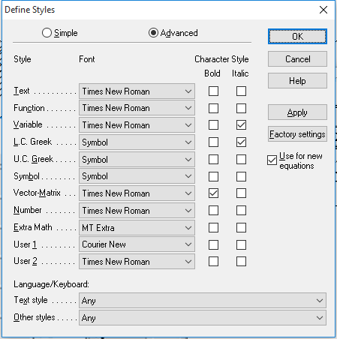
a
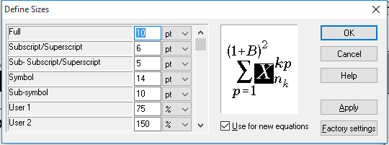
b
Fig. 2 Define of formulae: a – styles, b – sizes

4. Conclusions
1. Text, Text, Text¸ Text, Text, Text, Text, Text, Text, Text, Text, Text, Text. 2. Text, Text, Text, Text, Text, Text, Text, Text, Text, Text¸ Text, Text, Text. 3. Text, Text, Text, Text. Text, Text, Text¸ Text, Text, Text, Text, Text, Text. 4. Text, Text, Text, Text¸ Text, Text, Text, Text, Text, Text, Text, Text, Text.

References
- Baršauskienė, V., Mačerinskienė, I. (2009). Studijų darbų parengimo tvarka: mokomoji knyga. Kaunas: Technologija.
- Sperelakis, N. (2012). Cell physiology sourcebook: essentials of membrane biophysics (4th ed.). San Diego: Academic Press [accessed 4 April. 2021]. Available from Internet: https://www.sciencedirect.com/
- Padgurskas, J., et al. (2014). The effect of fluorine oligomer coatings on the tribocontacts of a piezoelectric actuator. Journal of Friction and Wear, 35 (1), 1–6.
(Author’s) Name SURNAME, Name SURNAME, Name SURNAME
Camera-Ready Articles Preparation Instructions for International Conference “Industrial Engineering 2021”
S u m m a r y
Dear authors,
Thank you for your interest in our international conference “Industrial Engineering 2021”. We work hard to meet your expectations.
Keywords: keyword, keyword, keyword.

